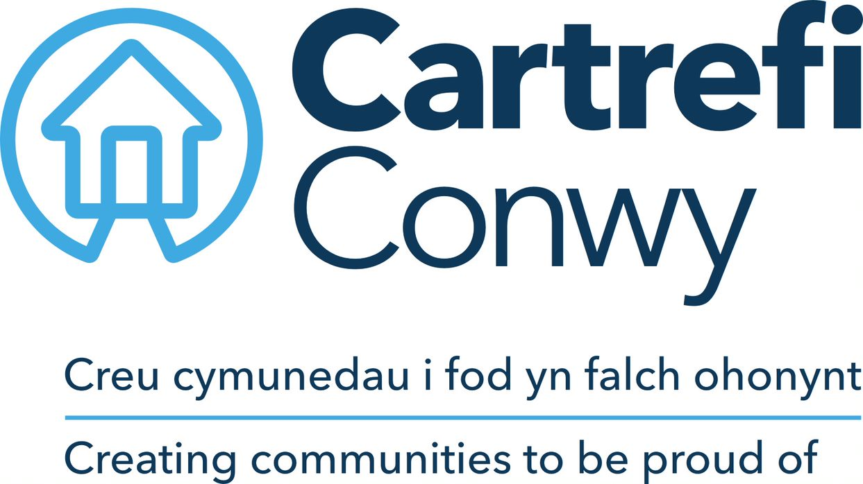

**Equality Monitoring Form**

**Why are we asking you this information?**

We, as a group, are committed to recruiting and retaining a workforce that reflects our diverse communities. It is important that we monitor and analyse diversity information so that we can ensure that we treat all colleagues and applicants fairly. Your cooperation enables us to make sure that we attract and retain a diverse and effective workforce.  
  
Any information on this form will be treated confidentially, in accordance with the General Data Protection Regulations and will be used for statistical purposes only. Our privacy notice will tell you more about how and why we use this information, you can find this on our website.

**1. How would you describe your ethnic group?**

Welsh, English, Scottish, Northern Irish or British

Irish

Gypsy or Irish Traveller

Roma

White and Black Caribbean

White and Black Caribbean

White and Asian

Indian

Pakistani

Bangladeshi

Chinese

Caribbean

African

Arab

Any other ethnic group, please state below:

Prefer not to say

**2. How would you describe your national identity?**

British

Welsh

English

Scottish

Northern Irish

Prefer not to say

Other nationality, please state

**3. What is your sex?**

Female

Male

Other, please state:

Prefer not to say

**4. Is your gender you identify with the same as your sex registered at birth?**

Yes

No, please state your gender identity:

Prefer not to say

Other gender identity please state:

**5. Which of the following best describes your sexual orientation?**

Straight / Heterosexual

Gay or Lesbian

Bisexual

Other sexual orientation, please state:

Prefer not to say

**6. What is your age group?**

16 – 24

25 - 34

35 - 44

45 - 54

55 - 64

65-74

75+ years

Prefer not to say

**7. What is your legal marital or registered civil partnership status?**

Never married and never registered a civil partnership

Married

In a registered civil partnership

Separated, but still legally married

Separated, but still legally in a registered civil partnership

Divorced

Formally in a civil partnership which is now legally dissolved

Widowed

Surviving partner from a registered civil partnership

Prefer not to say

**8. Do you have any physical or mental health conditions, illnesses or impairments lasting or expected to last 12 months or more?**

Yes

No

Prefer not to say

**If yes, do any of your conditions, illnesses or impairments reduce your ability to carry out day to day activities?**

Yes, a lot

Yes, a little

Not at all

Prefer not to say

**9. It helps us to know whether we are reaching all disabled people. If you ticked ‘Yes’ above please can you tick the relevant box(es) below.**

**You are welcome to tick more than one box if appropriate.**

Deafness or hearing impairment

Blindness or vision impairment

Physical disability/ impairment or mobility issues

Learning disability

Learning difficulty, such as dyslexia

Mental health condition, such as depression or schizophrenia

Social/communication impairment e.g Asperger's syndrome/other autistic spectrum disorder

Long term health condition, such as cancer, HIV, diabetes, chronic heart disease or epilepsy

A disability, impairment or medical condition that is not listed above, please state below

Prefer not to say

**10. Do you look after, or give any help or support to anyone because they have long term physical or mental health conditions, illnesses, impairments or problems related to old age?**

No

Yes, 9 hours a week or less

Yes, 10-19 hours a week

Yes, 20-34 hours a week

Yes, 35-49 hours a week

Yes, 50 or more hours a week

Prefer not to say

**11. What is your religion?**

No religion

Christian (all denominations)

Buddhist

Hindu

Jewish

Muslim

Sikh

Any other religion please state:

Prefer not to say

**12. Can you understand, speak, read or write Welsh? (tick all that apply)**

Understand spoken Welsh

Speak Welsh

Read Welsh

Write Welsh

None of the above

Prefer not to say

**13. What is your main language?**

English

Welsh

Other, please state below (including British Sign Language):

Prefer not to say

**14. How well can you speak English?\***

Very well

Well

Not well

Not at all

Prefer not to say